**PIZZA SALES SQL QUERY**

**KPI’S**

--s Total revenue by pizza sales

SELECT SUM(total_price) AS total_revenue FROM pizza_sales_updated;;



--AVERAGE PIZZA ORDER VALUE

SELECT SUM(total_price)/ COUNT(DISTINCT order_id) AS AVG_ORDER_VAL FROM pizza_sales_updated;



--Total Pizza Sold

SELECT SUM(quantity) AS Total_pizza_sold FROM pizza_sales_updated



--Total orders

SELECT COUNT(DISTINCT order_id) AS TOTAL_ORDER FROM pizza_sales_updated



--AVERAGE PIZZA PER ORDER

SELECT CAST(cast(SUM(quantity) as decimal(10,2))/CAST(count(DISTINCT order_id) AS DECIMAL(10,2)) AS decimal(10,2)) AS AVG_PIZZA_PER_ORDER FROM pizza_sales_updated



--daily trends by order day and total_orders

select * from pizza_sales_updated;

select datename(dw,order_date) as order_Day , count(distinct order_id) as total_orders from pizza_sales_updated

group by datename(dw,order_date);

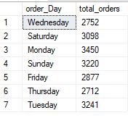

--monthly trend by highest order

select datename(MONTH, order_date) as Month_Name , count(distinct order_id) as Total_order from pizza_sales_updated

group by datename(MONTH, order_date)

order by Total_order desc;

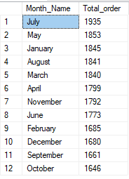

--sales percentage by pizza category

select pizza_category , sum(total_price)*100/(select sum(total_price) from pizza_sales_updated) as total_Sales_perc

from pizza_sales_updated

group by pizza_category;

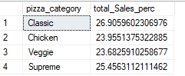

--percentage of sales by pizza size

select pizza_size, sum(total_price)*100/(select sum(total_price) from pizza_sales_updated) as sales_perc from pizza_sales_updated

group by pizza_size

order by sales_perc;

